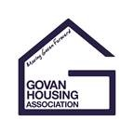

**Litter Pick**

Please phone or text to let us know you are coming, Susan on 07521 054411 or Gail on 07881 594891. We look forward to seeing you then.

Friday 31st March, 2.30pm  
Meet at 35 McKechnie Street, Govan or   
1 Cressy Street, Linthouse and finish inside the main gates of Elder Park

**Govan, Elder Park and Linthouse Community**

Help us keep our streets looking clean and tidy – and   
litter free

Tenants and staff of Govan, Linthouse and Elder Park Housing Associations are organising a community litter pick to support Keep Scotland Beautiful’s Spring Clean Campaign – equipment and refreshments provided