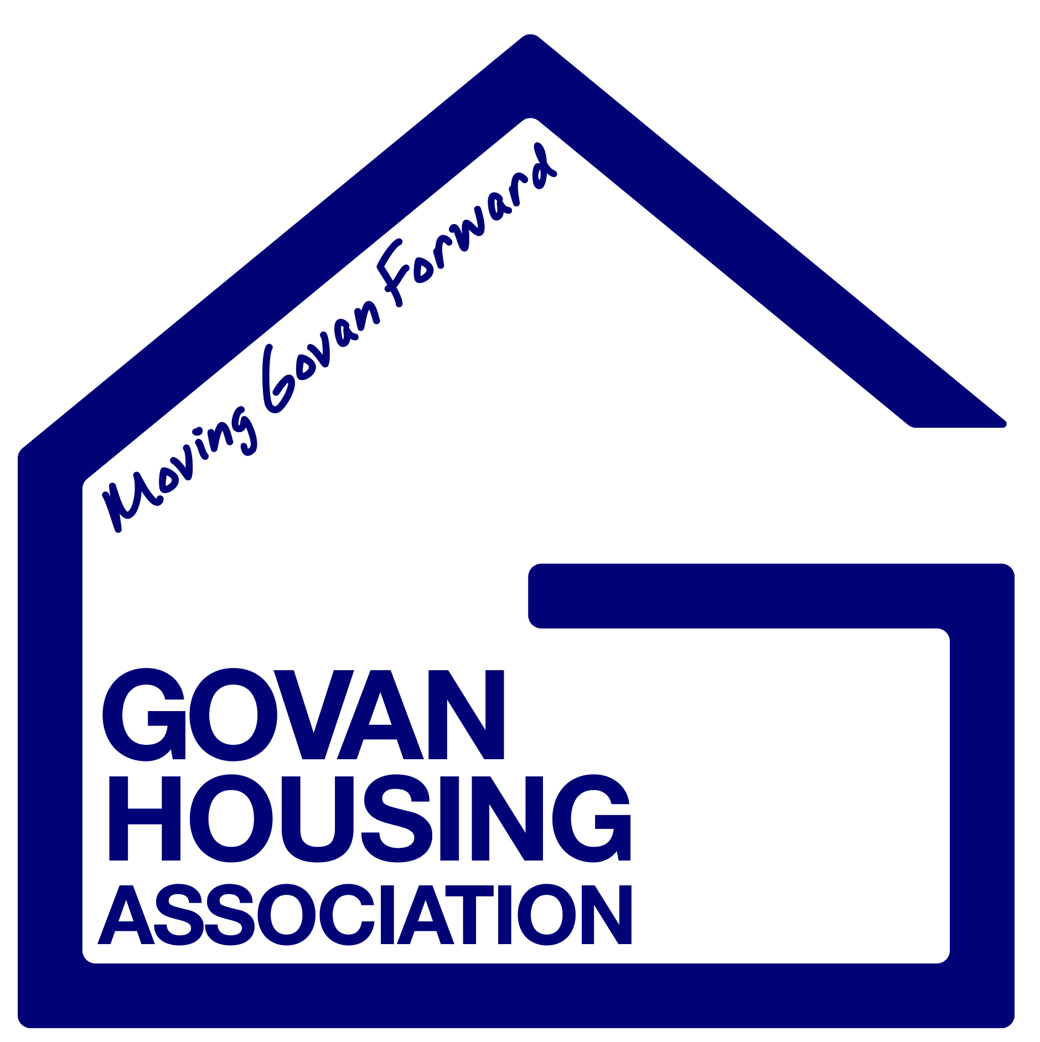

Estate Management

Policy Manual Section: | Housing Management
Policy Number: | OPERHM8
Scottish Social Housing Charter Reference: | 1. Equalities  3. Participation  6. Estate Management, anti-social behaviour, neighbour nuisance and tenancy disputes  11. Tenancy sustainment  13. Value for Money
Date Approved by Management Committee: | 26 January 2017
Next Review Date: | January 2020

Govan Housing Association can provide this document on request, in different languages and formats, including Braille and audio formats.

CONTENTS

1.0 Introduction

2.0 Aims and Objectives

3.0 General Principles

4.0 Equalities and Diversity

5.0 Legal and Regulatory Framework

6.0 Estate Management Standards

7.0 Review

1.0 Introduction

1.1 This policy aims to outline the way in which we propose to manage and maintain the environment in and around our housing stock so that they are pleasant places for our tenants and residents to live.

1.2 Govan HA promises to provide an estate management service which is consistent in its approach and responsive to applicants within the agreed target timescales ensuring that tenants have a complete picture of the available resources to deal with estate management issues.

1.3 The Association is committed to the principles of good corporate governance and sustainability and will endeavour to develop fair and consistent policies, procedure and practices.

1.4 Govan HA recognises that the environmental management and maintenance of our housing stock are integral parts of both housing management and maintenance functions. We have adopted this policy to ensure a common and consistent approach to these key activities.

1.5 The management of tenancies and estate management are linked activities; however activities such as the management of neighbour disputes and anti-social behaviour are covered by our Anti-Social, Neighbour Nuisance and Hate crime policy, which is available on request.

2.0 Aims and Objectives

In line with the Association’s visions, values and aims, this Policy aims:

- To promote good practice in the planning and delivery of the housing services

- To promote and facilitate inter agency co-operation as a means of meeting the housing, social and economic needs of the people of Govan.

- To maintain and sustain our properties and the developments in which they are located to an appropriate standard in line with our legal obligations and those obligations contained within the Scottish Secure Tenancy Agreement.

- To maintain an environment which is clean and tidy

- To respond to complaints and enquiries within a reasonable timescale.

- To monitor the quality of the service provided by our in house Estate caretakers and external contractors to check it is efficient and represents value for money.

- To work closely with all other agencies to provide effective estate management

- To ensure that those residents who are not our tenants but for whom we act as Factor get good value for money

2.1 Govan HA aims to be accountable to the community in which we operate. We invite tenants and others affected by its policies and procedures to provide any feedback to improve the Association’s service delivery. The Association has a Service Scrutiny Panel in its area of operation to review policies and to look at the standards operating in our area.

2.2 The purpose of the Estate Management Policy is to inform tenants as to the Policies and procedures operated by Govan HA and others to ensure that the area in which tenants live are safe, secure and high quality places. Estate management is not just about the physical environment but also includes advice and support to tenants and residents. It involves liaising and working with neighbouring residents and ensuring the environment is safe for others who may visit, use or enter Association land or property. A key priority is to ensure that where there are estate management problems that they are dealt with promptly either by Govan HA or in conjunction with other agencies to resolve the issue.

3.0 General Principles

3.1 The Association has agreed that estate management will include the following: -

- Provide advice and assistance to tenants on tenancy related issues and statutory requirements relating to estate management to help maintain their tenancies and the environment to the best of their ability

- Enforce tenancy conditions and deed of condition requirements relating to estate management in a firm, prompt and sensitive manner, using legal action as a last resort.

- Monitor empty properties, gardens and surrounding areas so that our community remains attractive and secure

- Consult with tenants and residents on estate management issues and ensure that services are appropriate and relevant to local needs

- Agree and meet standards for the management of communal areas and facilities and the upkeep of the physical environment in Association ownership

- Work with other agencies, including the statutory authorities to ensure estate management standards are achieved

- Provide advice and assistance to tenants and owner occupiers on services which enhance the local community, such as initiatives to reduce crime and improve the environment

- Ensure that estate management services are planned, adequately resources and effectively budgeted and controlled.

4.0 Equalities and Diversity

4.1 Govan Housing Association is committed to equality and diversity and will not discriminate in the operation of this policy on the basis of age; disability; gender reassignment; marriage and civil partnership; pregnancy and maternity; race; religion or belief; sex or sexual orientation.The Association will regularly test this policy for Equal Opportunity implications and take appropriate action, where necessary.

4.2 In line with our commitment to equal opportunities, this policy can be made available free of charge in a variety of formats including large print, translated into another language or on audio tape.

5.0 Legal and Regulatory Framework

5.1 Legislation

The following is a brief summary of the legislation that is taken into consideration when dealing with estate management issues:

- Human Rights Act 1998
- Data Protection Act 1998
- Housing (Scotland) Act 2001
- Housing (Scotland) Act 2010
- Equality Act 2010

5.2 Regulatory Guidance
The Housing (Scotland) Act 2010 asks Ministers to consult on and then set the outcomes that social landlords should achieve. The Scottish Social Housing Charter will be the document which contains these outcomes.
In formulating this policy the following Charter outcomes have been taken into consideration:

1: Equalities
Social landlords perform all aspects of their housing services so that every tenant and other customer has their individual needs recognised, is treated fairly and with respect, and receives fair access to housing and housing services.

2: Communication
Tenants and other customers find it easy to communicate with their landlord and get the information they need about their landlord, how and why it makes decisions and the services it provides

3: Participation
Tenants and other customers find it easy to participate in and influence their landlord’s decisions at a level they feel comfortable with.

6: Estate management, anti-social behaviour, neighbour nuisance and tenancy disputes
Tenants and other customers live in well-maintained neighbourhoods where they feel safe.

11: Tenancy sustainment
Tenants get the information they need on how to obtain support to remain in their home; and ensure suitable support is available, including services provided directly by the landlord and by other organisations.

13: Value for Money
Tenants, owners and other customers receive services that provide continually improving value for rent and other charge that they pay.

6.0 Estate Management Standards

The Association will operate in compliance with the following standards for Estate Management in our area of operation: -

6.1 Estate Inspections

6.1.1 All our staff has a duty in the course of their day to day work to note any repairs and issues which pose a threat to health and safety or where it may adversely affect the environment and report them to our maintenance team and/or other agencies. Responsibility for the condition and maintenance of our developments is shared between housing and maintenance.

6.1.2 The Association will carry out regular inspections of all our estates and common areas to ensure they are maintained to an acceptable standard and that residents comply with their tenancy conditions or deeds of conditions in this regard.

6.1.3 Where residents do not comply with their estate management obligations, we will endeavour to resolve the issues by means of liaising with residents involved and where necessary contact with other agencies. We will implement legal action only when all other avenues have been exhausted.

6.2 Communal Areas

6.2.1 The Association will ensure the cleanliness of common stairs and communal areas in its ownership in order to consider the safety and well-being of users through the encouragement and enforcement of tenant obligations. Where the Association has sole or majority ownership it will organise cleaning services where required. A detailed specification of the weekly cleaning service is available on request.

6.2.2 The Association will inspect communal areas on a regular basis to ensure agreed cleanliness standards are maintained. This will include closes, backcourt and common landscaped areas.

6.3 Common Landscaping

6.3.1 The Association has an in house Landscape Team who are responsible for maintaining the common landscaping in our developments to ensure these areas meet an acceptable standard. We may also utilise services of other agencies to ensure service standards are ensued. Although the terms of landscaping services provided will vary in each development, the following general standards will be maintained: -

- Communal grass will be cut on a regular basis between the months of April and November
- Shrubs and bushes will be pruned as and when necessary between April and October
- Shrub beds will be weeded and grubbed between April and October
- Weekly litter picks throughout the year
- Annual Weed killing will be carried out, including footpaths
- Work such as tree maintenance will be carried out where required
- Any vandalism, damage to plants or fencing will be reported to the maintenance team
- Grass edges will be reformed once per year at the start of the growing season
- Between the start of February and the end of March each year there will be two visits to clear shrub beds of litter and dead vegetation as required
- Between the start of February and the end of March each year there will be one visit to prune shrubs as required

6.4 Housing Stock

6.4.1 The Association has a planned maintenance programme which ensures our properties are regenerated periodically, ensuring compliance (where possible) with all Scottish Housing Quality Standards (SHQS) together with gas safety and electrical requirements. Regular surveys will be carried out ensuring the upkeep and improvement of our properties is continuous.

6.4.2 The Association will work with the Police Scotland to ensure where possible our properties and the surrounding communal spaces meet ‘Secure by Design’ standards. The Association also have challenging design standards. We expect contractors who tender for work to be able to meet the design standards which are set out, to use good quality materials to help ensure our developments reach the highest possible standards and are designed to be sustainable.

6.4.3 Tenants may from time to time apply to make alterations and improvements to their homes. Where written permission is granted we will require that any work carried out is to the highest standard and that it complies with current building and planning regulations. Reference can be made to the Association’s Decoration Allowances and Tenant Compensation for Improvements Policy.

6.5 Private Gardens

6.5.1 Many of our properties have private gardens. In line with the terms of the Scottish Secure Tenancy agreement we expect tenants to maintain these gardens to an acceptable standard by cutting any grass regularly and pruning any trees, shrubs and bushes as required. Housing staff are responsible for monitoring the condition of private gardens by visiting each development at regular intervals and encouraging tenants to maintain the gardens properly.

6.5.2 Where tenants fail to maintain their gardens to an acceptable standard they will be contacted by the Housing team and reminded of their obligation in their tenancy agreement. A reasonable timescale will be given to the tenant to bring their garden up to an acceptable level, with directions given as to certain works required.

6.5.3 Where a tenant is unable to maintain their garden they can apply to Glasgow City Council, Garden Assistance Programme for assistance. The following criteria will be taken into account: -

- The tenant is a registered Council Tax Payer
- The tenant is over 70 years of age
- The tenant is in receipt of state benefit relating to ill health or disability
- There is no other member of the household who is able to maintain the garden (aged 16- 69)

6.6 Car Parking

6.6.1 The Association is responsible for the maintenance of communal parking areas. Tenants and residents who have their own parking space are responsible for maintaining it in a clean and tidy condition.

6.6.2 Parking areas, spaces, gardens and/or communal areas should not be used for extensive car maintenance repair. The Association will only allow the keeping of commercial vehicles, trailers, caravans or boats in parking spaces, areas or in gardens following the prior granting of permission.

6.6.3 Abandoned or untaxed vehicles on Association property will be reported to the appropriate authority and removed where necessary.

6.6.4 The Association will not normally intervene in parking disputes between residents unless someone is in breach of their tenancy agreement due to the way they may be using parking facilities, they way they may behave towards other residents (i.e. where their actions are serious enough as to cause alarm and distress to other) or they are abusing facilities due to multiple vehicle ownership.

6.7 Refuse Disposal and Litter/Bulk Uplifts

6.7.1 Glasgow City Council Land Engineering Services (LES) are responsible for refuse disposal. The Association will, in conjunction with LES ensure that the appropriate facilities for the disposal of refuse are provided. The Association will maintain the communal refuse disposal facilities it has provided, such as bin stores and backcourt areas.

6.7.2 Residents will be advised of arrangements and appropriate days for the uplift of rubbish at the start of their tenancy and periodically through newsletters. Tenants are responsible for ensuring that their rubbish is disposed of safely, tidily and securely wrapped, and for making arrangements for the uplift of large items and garden refuse. The Association will liaise with EPS to take appropriate action on the illegal and unsightly dumping of rubbish and litter.

6.8 Pets

6.8.1 The Association aims to minimise any nuisance or health risk associated with the keeping of pets. The Scottish Secure Tenancy agreement determines the tenant’s responsibility in relation to pets and that tenants must obtain prior written permission to keep a pet in their property.

6.8.2 Application to keep a pet

Prior written permission from the Association is not necessary for the following: -

- Fish, reptiles or amphibians which is kept in a tank
- Small domesticated rodents such as rats, gerbils, chinchillas, guinea pigs, rabbits and hamsters
- Small domesticated birds such as parrots, cockatiels, finches, canaries, budgerigars

All applications to keep a pet will be assessed under the following criteria: -

- Any potential for disturbance, nuisance or distress that the pet may case to neighbours
- The size and type of accommodation where the pet is to be kept
- The number and type of pets already in the property
- Any history of pet related problems within the property

6.8.3 Restrictions to keeping pets

- Pet Owner’s will not be granted permission to keep a dog which is prohibited by the Dangerous Dogs Act 1991 or by any other Statute or Regulation.

- Pet Owner’s will be held responsible for the behaviour of any pets owned by or living with them. It is expected that tenants take all reasonable steps to supervise and keep such pets under control and ensure they do not cause nuisance to neighbours or deterioration to the condition of the property, common parts or the vicinity of the house. This includes fouling, noise or smell from the animal. The Association will recharge for any costs incurred as a result of damage or cleaning up any mess left.

6.9 Vermin and Pest Control

6.9.1 The Association aims to keep all properties in its ownership free from vermin and pest infestation. Tenants and residents however, have a responsibility to keep the property and surrounding areas in a good clean condition so as not to attract vermin.

6.9.2 Where cases are reported to us of infestations of vermin or pests in tenant’s homes our staff will respond promptly to these by signposting residents to Environmental Health Services (EHS). The Association may carry out eradication work based on advice from EHS.

6.10 Satellite dishes, televisions and cable aerials

6.10.1 The Association provides communal Satellite dishes to all of our properties to allow residents to enjoy Satellite TV.

6.10.2 As Govan is classed as a conservation area permission to erect individual satellite dishes will not be granted. The Association will take reasonable steps to consult with tenants on the removal of such dishes.

6.11 Graffiti and Vandalism

6.11.1 The Association aims to minimise the incidence of vandalism and to respond promptly when incidents are reported. We will make good any damage caused by vandalism which is not the responsibility of the tenant or has been inflicted on empty properties in the ownership of the Association.

6.11.2 The tenant is responsible for making good or paying for damage caused by deliberate acts of vandalism by themselves, any member of their household or visitors. We will assess the extent of malicious damage and take action required within the agreed repairs time-scales. More information on this is provided within the Association’s Rechargeable Repairs Policy.

6.11.3 The Association will view any malicious damage that has been carried out by a tenant as a very serious breach of the Tenancy Agreement and where it has been proven that the damage was caused by a tenant, action would be taken under the Associations Anti-Social behaviour, neighbour nuisance and Hate Crime Policy.

6.11.4 Graffiti of an obscene, racist or sectarian nature will be removed within 1 working day. Photographs will be taken and kept as a record of graffiti of this nature. The Association will ensure that all properties are adequately insured against vandalism and that all incidents are reported to Police Scotland and/or any other agency as required.

7.0 Review

7.1 This Policy is scheduled for review every 3 years and will take account of: -

- Legislative, regulatory and good practice requirements
- Association performance
- The views of tenants, other residents, staff and members of the Association’s Management Committee.

