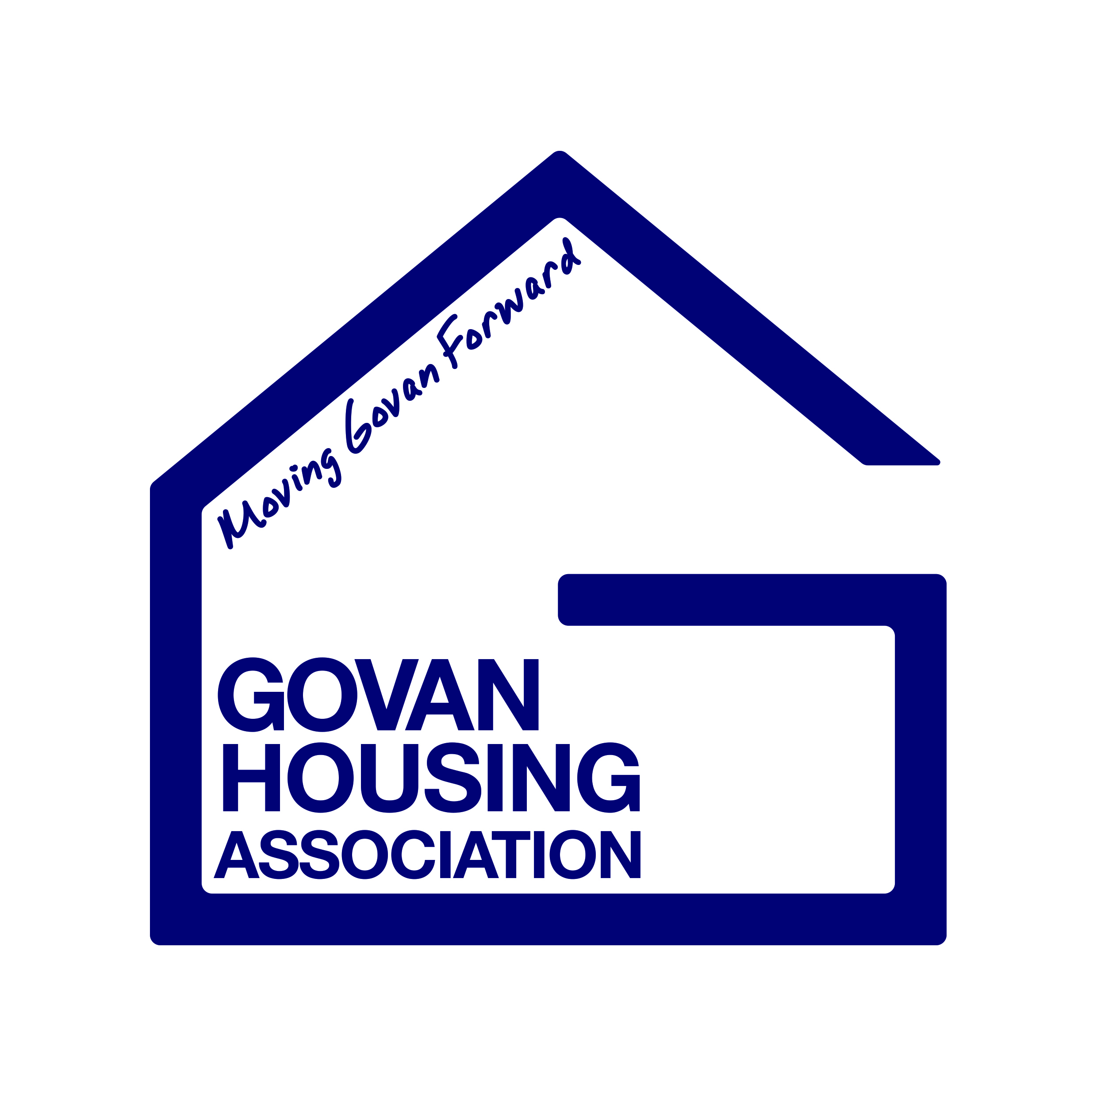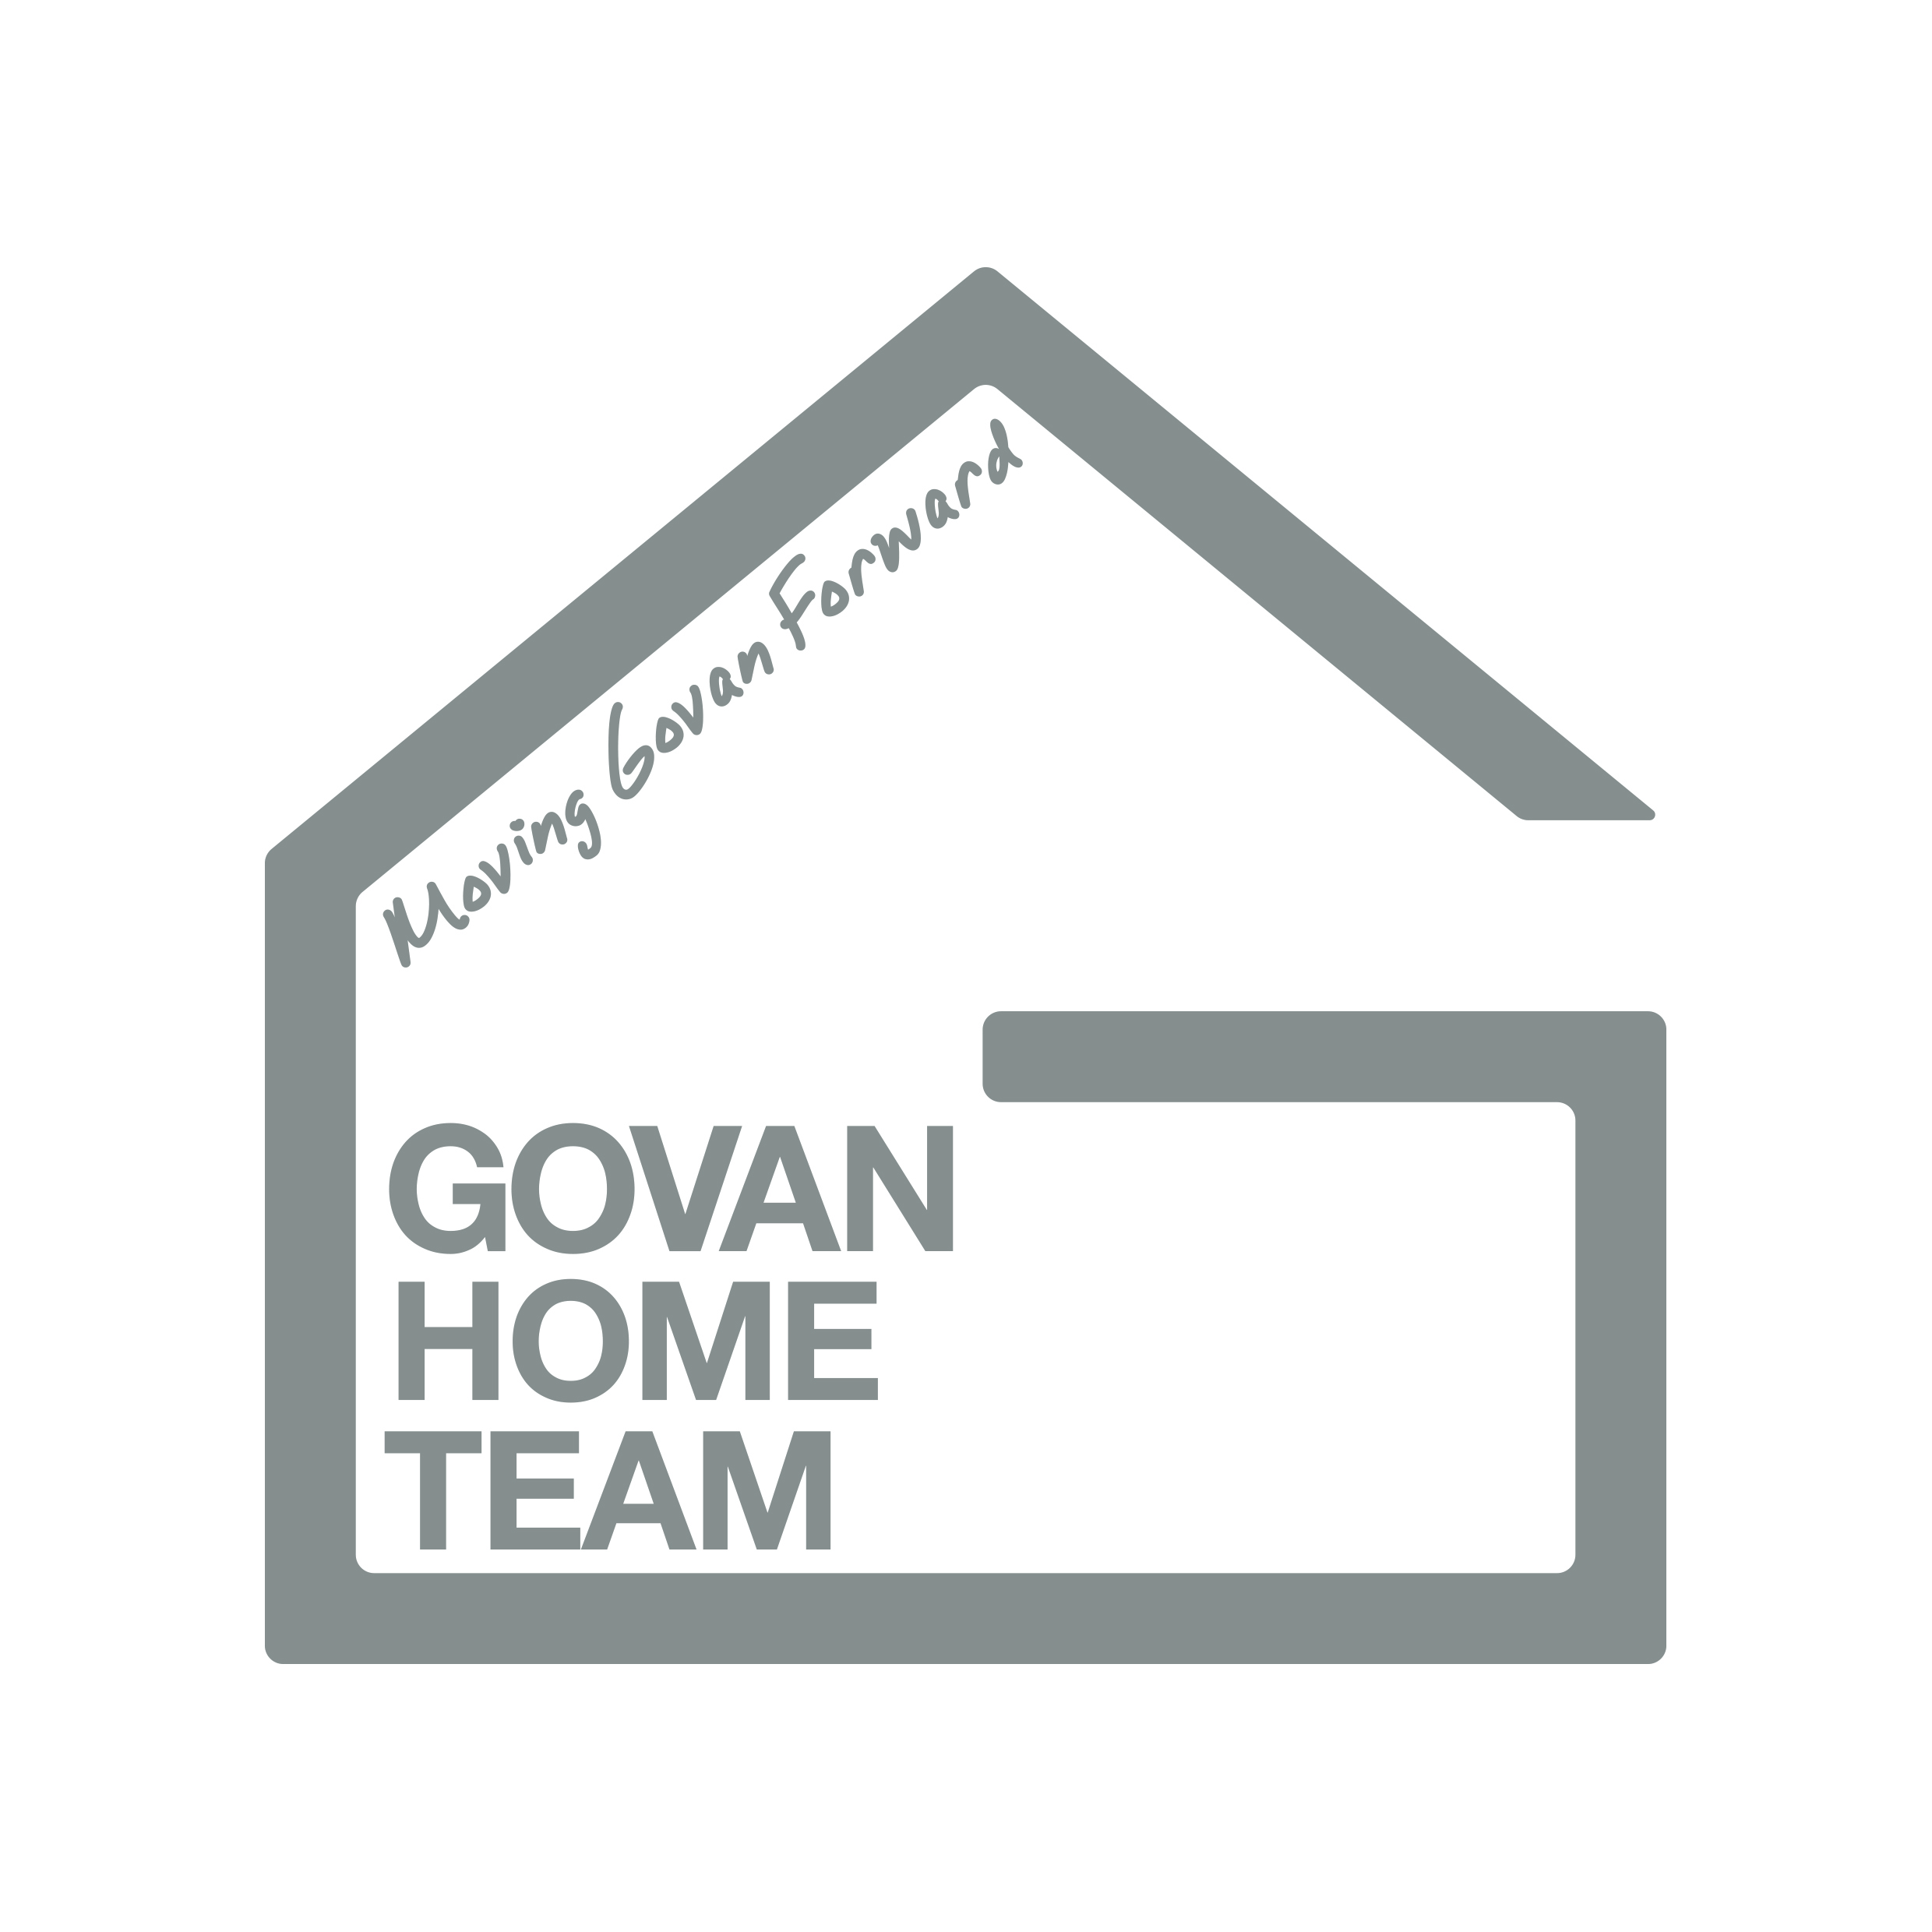
Govan Housing Association &
Govan HOME Team

Freedom of Information
Publication Scheme and Guide to Information

November 2019
Policy Manual Section: | Governance
Policy Number:
Scottish Social Housing Charter Reference: | 1. Equalities  2. Communication  3. Participation
Regulatory Framework Reference | AN3/TS2/EH1/OC1 and RG 2.3
Date Approved by Management Committee:
Next Review Date:

Govan Housing Association can provide this document on request, in different languages and formats, including Braille and audio formats.

Contents

1. Terms Used
2. Background

3. Fees Notice
4. Formats other than online and Charging Schedule
5. Information we cannot publish
6. For how long will information be published?
7. Copyright and re-use
8. Contact us
9. Classes of Information

The information that we make available to you

Class 1: About Lochaber Housing Association Group

Class 2: How we deliver our functions and services

Class 3: How we take decisions and what we have decided

Class 4: What we spend and how we spend it

Class 5: How we manage our human, physical and information resources

Class 6: How we procure goods and services from external providers

Class 7: How we are performing

Class 8: Our commercial publications

Class 9: Our open data

1. Terms used
A definition of terms and acronyms used throughout the context of this document.
Terms Used | Explanation
FOISA | The Freedom of Information (Scotland ) Act 2002  This legislation places a duty on those organisations covered to proactively publish certain types of information; and to respond to requests for information; and to provide advice and assistance to those making requests for information.
EIRs | The Environmental Information (Scotland ) Regulations 2004  This legislation places a duty on those organisations covered to proactively respond to requests for environmental information.
SIC | The Scottish Information Commissioner  Responsible for ensuring that those bodies covered by FOISA and EIRs comply with the terms of the legislation.
Model Publication Scheme (MPS) | A standard framework for authorities to publish information under FOISA approved by the Scottish Information Commissioner
Guide to Information | Guide to Information  A guide that all organisations subject to FOISA and adopting the MPS must produce to help people access the information it makes available.
Classes of Information | Nine broad categories describing the types of information authorities must publish ( if they hold it)

2. Background - The Freedom of Information (Scotland) Act 2002 (FOISA)
2.1 (FOISA) requires that all housing associations/co-operatives in Scotland must produce and maintain a publication scheme. This must detail all of the key information that we publish and how you can access it.
2.2 This Guide to Information is our publication scheme, and contains links to where you can find all of the information listed online. Govan Housing Association has adopted the Scottish Information Commissioner’s (SIC) Model Publication Scheme (MPS), and this Guide has been approved by the SIC.
3. Fees Notice
Under both FOI and EIRs we may charge requesters a fee for complying with their requests. However, fees are dealt with differently under each regime.
3.1 Freedom of Information
Fees must be handled in accordance with the Freedom of Information (Fees Required for Disclosure) (Scotland) Regulations 2004 (the “Fees Regulations”).
In accordance with the Fees Regulations we may only charge for locating, retrieving and providing requested information (so for example, staff time spent searching files/computer systems and redacting documents).
When calculating charges we must consider: how many staff members will be required to deal with the request; how long will it take us to carry out the required tasks; and what is the hourly rate (capped at £15.00 per hour). Where it costs us less than £100.00 to comply with a request we will not charge the requester and where our costs amount to between £100.00 - £600.00 we will only charge 10% of your costs.
You should refer to the Fees Regulations and the SIC’s guidance, available here, for more information on how we will deal with charges under FOI.
3.2 Environmental Information Request
As with Freedom of Information (FOI), it is possible to charge a fee for providing environmental information on request, although the specific charging rules are different. In particular, in marked contrast to FOI, there is no upper or lower limit to the fee which may be charged. Instead the Regulations merely state that the fees shall not exceed “a reasonable amount” and must not exceed the actual costs of producing the information requested.
It is possible (as with FOI) to require payment in advance of providing the information, but written notice of this fact (equivalent to an FOI fees notice) must be given to the applicant, who then has 60 working days to pay. The compliance timescale clock is stopped during this time. The Association is obliged to publish a Schedule of Fees and information on circumstances in which a fee may be charged, waived or required to be paid in advance.
We are not permitted to charge for allowing access to registers of environmental information, or for allowing an applicant to examine information at the Association’s offices (as opposed to being given a copy of it).
The following is Govan Housing Association’s Schedule of Fees for purposes of the Environmental Information (Scotland) Regulations 2004:
Costs of locating, retrieving and assembling information: - Chargeable elements will be included in the calculation in accordance with the Freedom of Information (Fees for Required Disclosure) (Scotland) Regulations 2004, but without any disregard for the first £100 and without any discount on the elements above £100; - Staff costs will be charged on the basis of the actual cost to the Association of employing the staff in question for the time spent.
This means the Association will calculate the fee for an environmental information request on the basis of the same elements as can be included in the fees for compliance with FOI requests. However in contrast to mainstream FOI fees, actual staff time is not capped at a maximum of £15 per hour but is charged at the actual cost. The lowest grade member(s) of staff available to carry out the task (being of an appropriate grade to be dealing with the information in question and having the requisite skills and knowledge) will be used.
3.3 Formats other than on-line and charging Schedule
In addition the fee will include any costs associated with putting the information into a particular format, copying and postage costs, as set out below.
FORMAT | CHARGE
Online | Free
View at our office | Free
Print in black and white | 10p per sheet – A4  20p per sheet – A3
Print in colour | 20p per sheet – A4  40p per sheet - A3
CD rom | 50p
Posted document | Cost of postage

Situations requiring payment in advance: - all fees for environmental information requests require to be paid in advance.
This is to maintain consistency with the FOI rules.
3.4 Situations where the fee may be waived
The Association may elect to waive the fee if satisfied that there is a genuine and widespread public interest in the publication of the information in question. This is unlikely to be the case where a request appears to be driven by commercial interests or is highly specific in terms of focus or geographical area.
The Association may elect to waive the fee if satisfied that it would be uneconomical to issue a fees notice and process payment.
The Association may elect to waive the fee where information is requested which consists of a mixture of environmental and non-environmental information, and the non-environmental information would not be subject to a fee in terms of the FOI legislation.
The Association may elect to apply a disregard of the first £100 of any fee and charge only 10% of the marginal costs between £100 and £550 if it has processed environmental information request as a mainstream FOI request. This should not be taken as an indication that the same disregard will be applied to any similar requests in future. A fee may be charged in all other cases based on the full chargeable elements.
We may charge a ‘reasonable amount’ for complying with requests under the EIR – however the charge will not exceed our costs for producing the information requested. We cannot charge for allowing people to access Environmental Information via public registers or at a place where we keep said information available for inspection (for example at our office).
5. Information we cannot publish
We will publish all the information we hold that falls within the classes of information. If a document contains information that is exempt under Scotland’s freedom of information laws, we will remove or redact ( black out) the information before publication and explain why. Whilst we will try to make all of the information we have detailed available, in rare cases there may be some information that we cannot make available. For example, sometimes if we were to publish certain board minutes, it could reveal personal details about an individual. This would be a breach of Data Protection legislation if we were to do so. When this is the case, we will remove any personal details before publication and highlight where and why we have done so.
6. For how long will information be published?
We aim, where possible, to publish information for at least the current and previous two financial years. When we review any document – e.g. our policies – to avoid confusion we will only publish the current version once it has been updated.

7. Copyright and Re-use
Where we hold the copyright on our published information, the information may be copied or reproduced without formal permission, provided that:
● It is copied accurately o It is not used in a misleading context
● The source of the material is identified
8. Contact Us
If you have any queries about anything contained within this Guide to Information, or if there is some information that you cannot find that you would like to access, please contact: Govan Housing Association, 35 McKechnie Street, Glasgow, G51 3AQ.
Email: general@Govanha.org.uk
Telephone: 0141 440 0308
Website: www.Govanha.org.uk
Repairs and Maintenance: https:xxxxxxxxxxx

9. Classes of Information
CLASS 1 - About Our Organisation, Govan Housing Association Group
Information about who we are, where to find us, how to contact us, how we are managed and our external relations.
Descriptions of who we are
Govan Housing Association and Govan Home Team
Our Mission Statement
Our Vision and Values
Corporate Objectives
Strategic Objectives
Senior Management Team
Organisational Chart
Area of operation
Business Plan
Customer Charter
Contact Details

About our Governing Body
Governing Body Details
How to become a a part of the Governing Body

Contact details
Contact details and opening hours Govan HA / Govan Hometeam
How to make a complaint and contact details

Information relating to Freedom of Information
Publication Scheme and Guide to Information
Fees Notice for published information
Freedom of Information (FOI) and Environmental Information Policy
How to make a FOI request
How to make a Subject Access request
How to make an Environmental Information request (EIR)
Charging Schedule for providing information under an EIR
Governance Documents and Corporate Policies
Rules
Standing Orders
Membership Policy
Code of Conduct for Staff
Code of Conduct for Governing Body Members
Entitlements, Payments and Benefits Policy
Equalities Policy
Health and Safety Policy
Register of Interests – available on request
Relationship with Regulators
Engagement Plan with Scottish Housing Regulator
Assurance Statement
Annual Return on Charter
Financial Returns to Scottish Housing Regulator
Charter Report to Tenants
Internal and External Audit Arrangements

CLASS 2 – How We Deliver Our Functions and Services
Information about our work, our strategy and policies for delivering services and information for our service users.
How to use our services
How to Report a Repair
Right to Repair
How to apply for a tenancy
Tenancy support
How to contact Housing Management
How to make a complaint
How we consult with tenants and other customers to improve and develop new services
Policies and procedures
Allocations Policy
Anti-Social Behaviour Policy
Asbestos Management Policy – on request
Asset Management Strategy – currently under review – on request
Customer Charter
Data Protection Policy
Environmental Information Regulations (EIR) Policy – available from 29th November 2019
Equality and Diversity Strategy - currently under review – on request
Estate Management Policy – currently under review – on request
Health and Safety Policy
Procurement Policy
Risk Management Policy
Rent Setting Policy - currently under review – on request
Rent Arrears Policy - currently under review – on request

CLASS 3 – How We take Decisions And What We Have Decided
Information about the decisions we take, how we make decisions and how we involve others.
Governing Body meetings
Governing Body agendas – on request
Governing Body meeting minutes – GHA/Govan Home Team - on request
Governing Body meeting reports – on request

Consultation and participation
Tenant participation strategy – on request
Tenant consultation reports – on request
Tenant scrutiny panel minutes – on request
Registered tenant organisations – minutes – on request

CLASS 4 – What We Spend and How We Spend It
Information about our strategy for and management of, financial resources (in sufficient detail to explain how we plan to spend public money and what has actually been spent).
Information about our accounts and budgets
Financial Management policies and procedures–available on request
Budget policies and procedures – available on request
Audited Accounts GHA and GHT – available on request
Annual Report and Financial Statements

Our programme of work and projects
Project funding – on request
Capital works programme – on request
Spending relating to Staff and Governing Body
Travel and Subsistence Policy
Senior Staff - expenses – on request
Board member expenses – on request
Pay and grading structure
Pension Scheme
CLASS 5 – How We Manage our Human, Physical and Information Resources
Information about how we manage our human, physical and information resources.
Human resources
Staffing structure GHA & GHT
Salary and grading scales
Pension Arrangements – available on request
Recruitment Policy
Training and Development Policy - available on request – under review
Adoption, Maternity, Paternity and Shared Parental Leave - Available on Request
Alcohol Drugs & Substance Abuse Policy - Available on Request
Attendance Management Policy - Available on Request
Code of Conduct – Governing Body Members, Staff
Disciplinary Policy - Available on Request
Disclosure Handling Policy - Available on Request
Equal Opportunities Policy
Flexible Working Policy - Available on Request
Entitlement, Payments and Benefits Policy
Redundancy Policy Available on Request
Dignity at Work Policy Available on Request
Smoke Free Policy Available on Request
Social Media Policy Available on Request
Staff Uniform Policy Available on Request
Stress Policy Available on Request
Whistleblowing Policy
Retention Schedule

Information resources
Document Retention Schedule – on request
Data protection and Privacy Policy
Freedom of Information Policy

CLASS 6 – How We Procure Goods and Services From External Providers
Information about how we procure works, goods and services, and our contracts with external providers.
Our procurement
Procurement Policy
Public Contracts Scotland Notices
Regulated procurement contracts awarded
Our contractors and suppliers
Key service delivery contractors – on request
Approved suppliers and contractors used by GHA Group – on request
Contracts Register – on request
Framework Agreements

CLASS 7 – How are We Performing
Information about how we perform as an organisation and how well we deliver our functions and services.
Annual Report
ARC report to tenants
Performance reports
Benchmarking information
Complaints Policy and guidance
Tenant scrutiny reports – on request
Newsletters
CLASS 8 – Our Commercial Publications
Information packaged and made available for sale on a commercial basis and sold at market value through a retail outlet e.g. bookshop, museum or research journal.
This class does not apply to Govan Housing Association Group as we do not produce any publications for sale.
CLASS 9 – Our Open Data
Open data made available by us under Scottish Government’s Open Data Resource Pack and available under open licence.
This class does not apply to Govan Housing Association Group.

