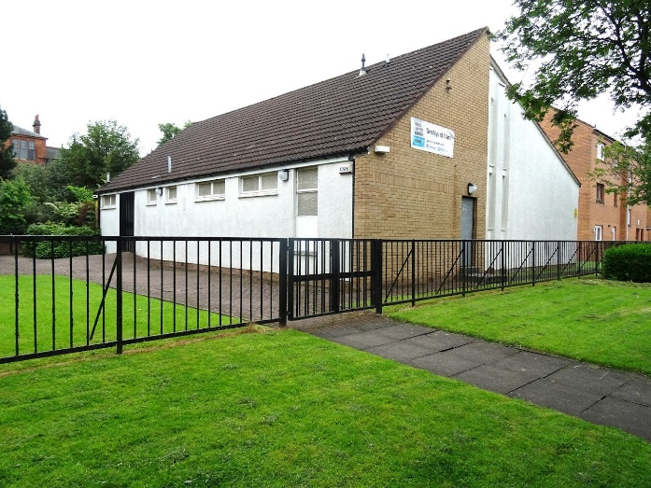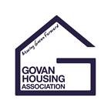

Join staff and residents on an estate walkabout of the Govan C area to raise and discuss any estate management queries with Govan Housing Association.

For more information or to let us know you will be attending please phone 0141 440 0308 or email community@govanha.org.uk

First Friday of every month at 2pm.

Meet at Grace Baptist Church   
425 Govan Road

**Govan C**

**Estate Walkabouts**